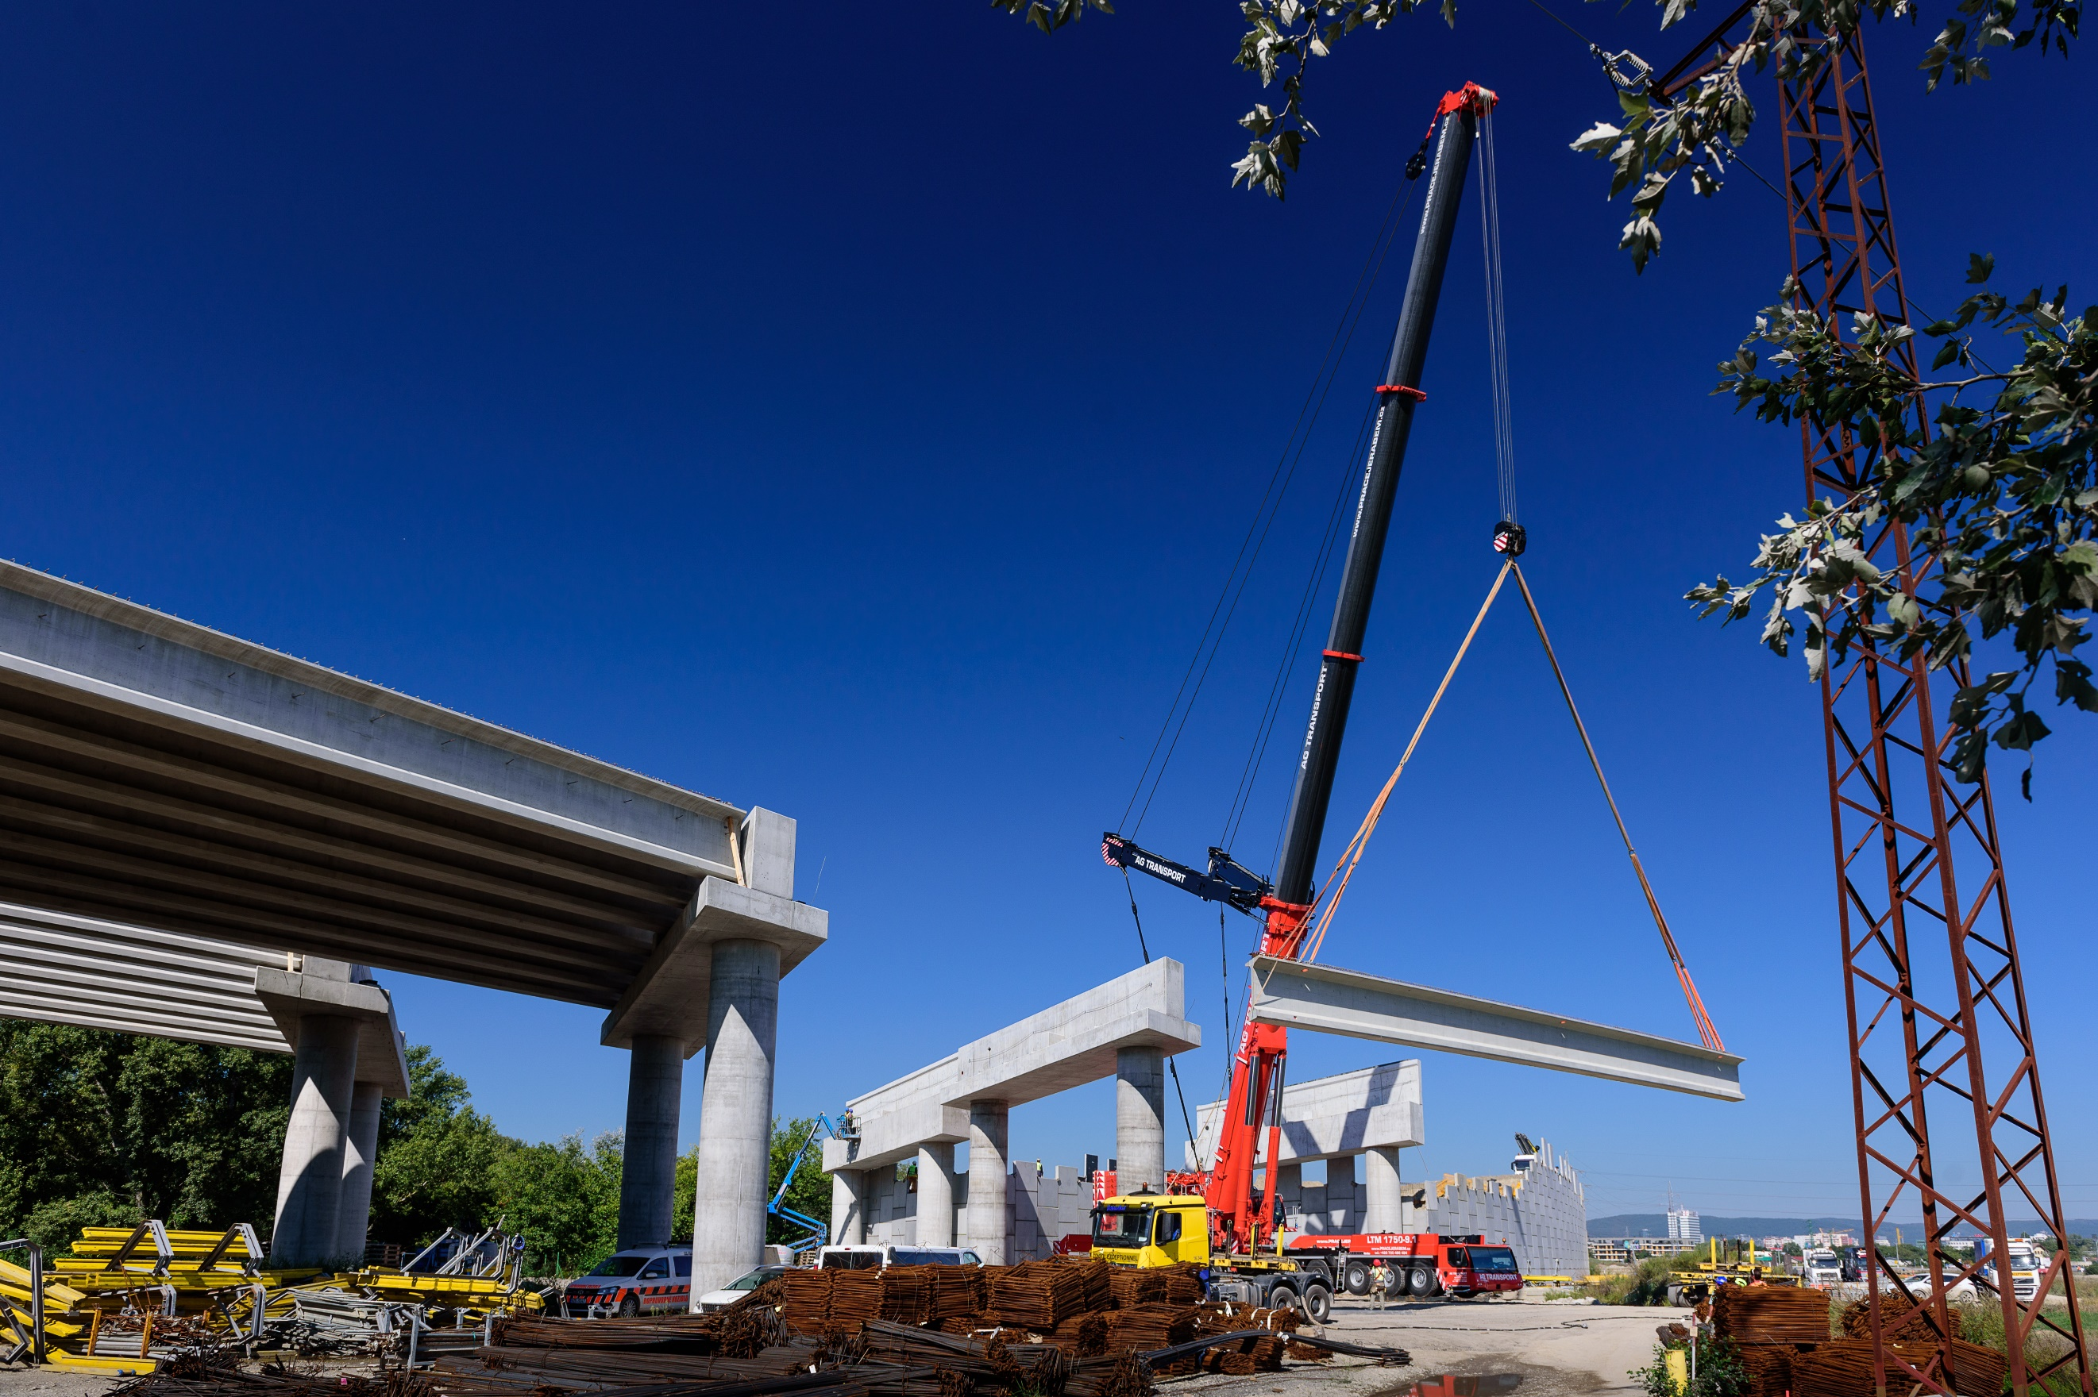


INTEGRATED MANAGEMENT SYSTEM POLICY

January 13, 2021

AG TRANSPORT, s.r.o.
Průmyslová 1141,
686 01 Uherské Hradiště
Czech Republic

AG TRANSPORT is a leading provider of international road transport services, crane and rigging services and heavy haulage transport services.
Our mission is to be the Global Partner of choice for impactful, experience-enhancing and sustainable transport and crane services – energizing customers, connecting with consumers and inspiring employees to push boundaries.
Our vision is to redefine what’s possible with packaging – for consumers, businesses and the planet.

Integrated Management System Policy Objectives

- uncompromised quality, safety, environmental and health performance,
- strive excellence by increasing the efficiency of key processes with continuous improvement culture and ensuring competences and knowledge availability,
- provide safe working conditions for the employees, visitors and service providers,
- protection of the environment, including prevention of pollution and sustainable resources use,
enable growth of the whole company and constant strengthening market position by excelling in customer satisfaction.

We Realize These Objectives

- regular review and continuous improvement of provided services quality and safety, environment and occupational safety management systems according to the relevant regulations and standards,
- complying with applicable legislative and other compliance obligations,
- promote quality and safety culture to meet and exceed customers’ expectations and aiming to ‘zero defect and zero accidents’
- prevention of work-related accidents, injuries, near miss, ill health, occupational diseases by eliminating hazards and reduce Occupational Health & Safety risks to which AG TRANSPORT employees and visitors are exposed,
- close cooperation, consultation and participation of employees in activities, affecting their safety and health and improvement of the Occupational Health & Safety management system,
- reducing consumption of natural resources, energy, amount of waste and promote sustainability,
- continuous analysis of hazards and opportunities for improvement of the areas generating significant risks related to AG TRANSPORT activities,
- promoting a culture of innovation and creativity through continuous improvement of our processes, products and services,
- business development and growth, together with considering values of social, ethical and environmental responsibility.
The Integrated Management System Policy is the framework for setting quality, environment and occupational health and safety objectives to support customer satisfaction, AG TRANSPORT’s strategy and sustainable growth.
The AG TRANSPORT Executive provides resources and means necessary to implement the Integrated Management System Policy, its regular reviews of efficiency and guarantees that the Policy is communicated, understood and observed by all employees and available to interested parties.
Values and responsibilities of the AG TRANSPORT in scope of environment and industrial safety are described in the „AG TRANSPORT Environmental and Health & Safety Policy”.

13.01.2021  Uherské Hradiště, CZ | 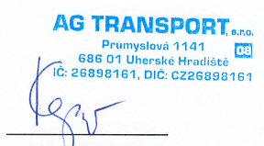  Mgr. Tomáš Kepič  managing director

