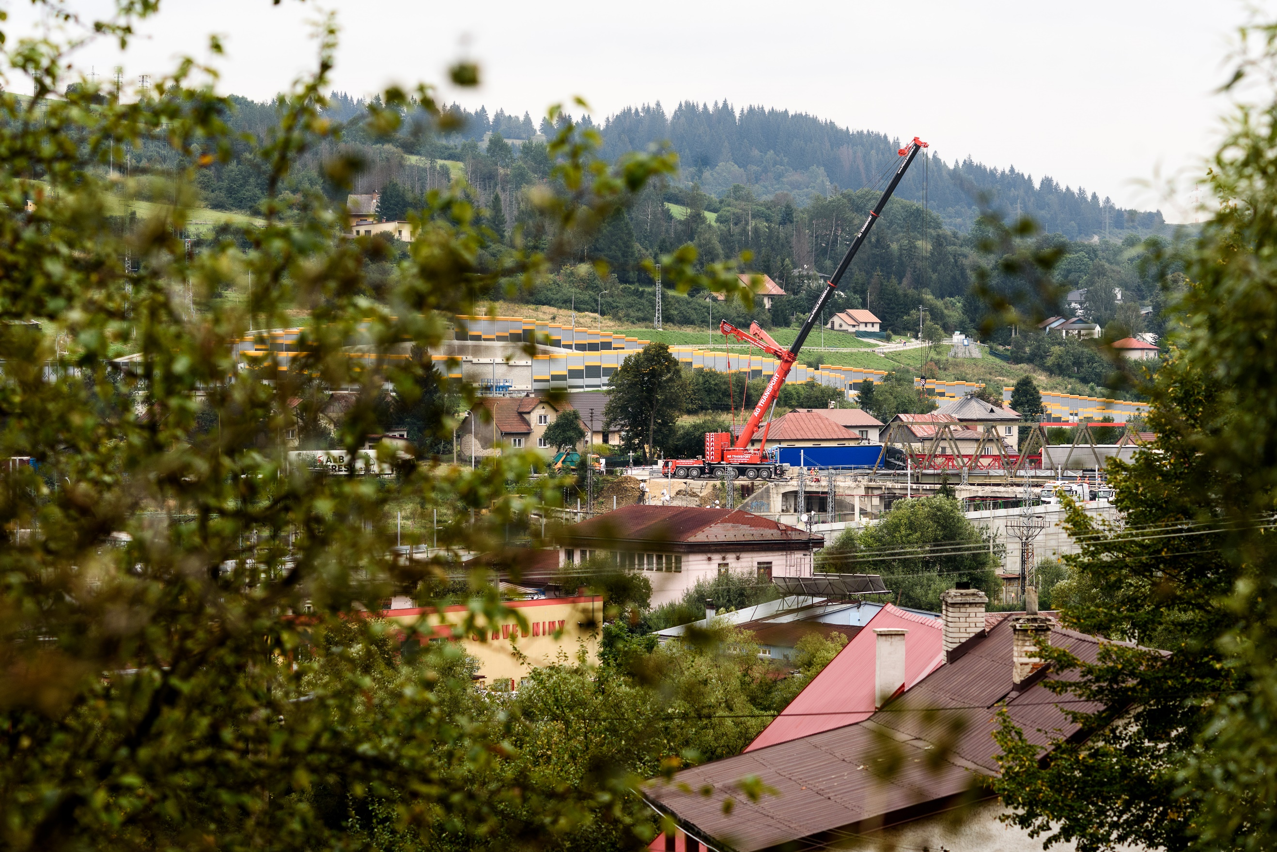


Conflict Minerals Due Diligence Report

January 15, 2021

AG TRANSPORT, s.r.o.
Průmyslová 1141,
686 01 Uherské Hradiště
Czech Republic

Introduction

In line with our three sustainability pillars: care, sustain and recycle, we are committed to procuring ethically and environmentally sustainable raw materials. As such we prohibit the procurement of materials containing minerals which originate from entities which finance conflicts or benefit armed groups specifically in the Democratic Republic of the Congo or adjoining countries. The extraction of these minerals often entails human rights infringements including using forced labor and abuse of women and children. These so-called conflict minerals include tungsten, tantalum, tin and gold and are known as 3TG.

Due Diligence Process Design and Company Management Systems

To ensure a more structured approach to the issues surrounding Conflict Minerals, in 2021, AG TRANSPORT put in place a Conflict Minerals Policy which is publicly available on our website. The company’s Procurement Office, in cooperation with AG TRANSPORT’s Sustainability Office, is responsible for implementing the policy.
To ensure the tin we use is sourced from conflict-free areas, we follow strict procedures based on applicable national and international guidelines, including "Due Diligence Guidance for Responsible Supply Chains of Minerals from Conflict-Affected and High-Risk Areas” issued by the OECD.
We have implemented the following preventative measures:
- All of our suppliers are required to sign our Supplier Code of Conduct,
- we require our suppliers of components, parts or products which contain tin (or any other conflict minerals as may be or become applicable) to obtain it from conflict-free sources,
- this policy is available to our suppliers, and we expect them to establish similar guidelines for their own suppliers,
- suppliers are expected to establish a strict due diligence process to ensure compliance throughout their own supply chain.

Identification and Assessment of Supply Chain Risk

AG TRANSPORT requests all its strategic materials suppliers to complete an extensive self-assessment questionnaire which covers, amongst other topics, Conflict Minerals issues. All relevant suppliers must submit a formal statement regarding conflict minerals usage and they are asked to verify this signed statement.

Response to Supply Chain Risk

Should AG TRANSPORT suspect that a supplier is procuring or using tin (or any other conflict minerals as may be applicable) from a source that directly or indirectly finances or benefits armed groups in conflict areas, AG TRANSPORT will inform the supplier in writing and give the supplier a reasonable amount of time to correct the non-compliance by submitting certificates of origin to prove the non-use of such mineral(s) from such conflict areas. Should a supplier fail to provide the appropriate evidence, correct use or procurement practices in violation of this policy, or is found to have provided false information, AG TRANSPORT reserves the right to terminate its business relationship with the supplier in question. All employees are required to report any suspicions shall contact AG TRANSPORT directly or via the speak-up procedure.

Support for Smelter Due Diligence

As AG TRANSPORT does not directly purchase tin, tungsten, tantalum, or gold; and given that its direct suppliers do not smelt or refine these metals at their premises’, AG TRANSPORT does not conduct on-site audits related to Conflict Minerals. Instead, we rely on and monitor audits and information provided to us by our direct suppliers.

15.01.2021  Uherské Hradiště, CZ | 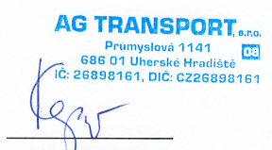  Mgr. Tomáš Kepič  managing director

